Program Evaluation and Review Technique (PERT) is a method used to examine the tasks in a schedule and determine a Critical Path Method variation (CPM). It analyzes the time required to complete each task and its associated dependencies to determine the minimum time to complete a project. It estimates the shortest possible time each activity will take, the most likely length of time, and the longest time that might be taken if the activity takes longer than expected. The US Navy developed the method in 1957 on the Polaris nuclear submarine project.
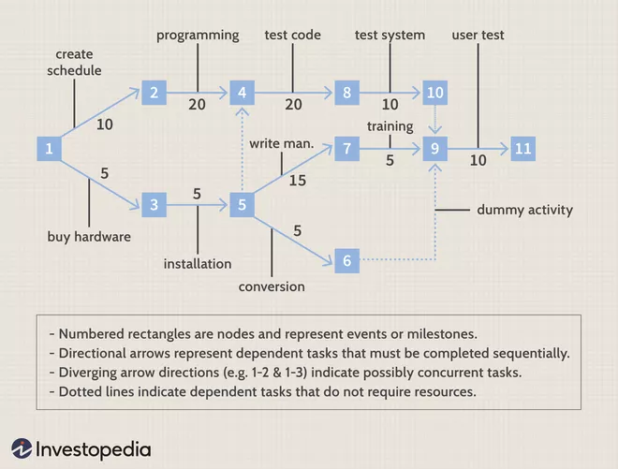

Facts About PERT
- PERT is a probabilistic project management tool.
- PERT is an event oriented tool, whereby the network interest is focused upon start or completion of events and not on activities themselves.
- PERT is useful for research and development project as they comprise of the unpredictable tasks and activities.
- PERT technique involves use of words like events, network diagram and slacks.
- PERT does not categories activities into critical and non-critical activities.
- In PERT, duration of activities are not estimated with a fair degree of accuracy (activities are not so accurate and definite).
- In PERT, allowance is made for uncertainties in the duration of time involved.
- In PERT, time is not related to cost.
- PERT is suitable in defense projects and R&D where activity time cannot be reliably predicted.

Purpose of PERT Analysis
PERT Analysis informs Program Managers and project personnel on the project’s tasks and the estimated amount of time required to complete each task. By utilizing this information a Program Manager will be able to estimate the minimum amount of time required to complete the entire project. This helps in the creation of more realistic schedules and cost estimates.

How to Conduct a PERT Analysis
There are two main steps when determining the PERT Estimate. These two steps are:
- Step 1: Determine optimistic, pessimistic, and most likely estimates
- Step 2: Calculate PERT Estimate using the PERT Formula

Step 1: Determine optimistic, pessimistic, and most likely estimates
To conduct PERT Analysis, three-time estimates are obtained (optimistic, pessimistic, and most likely) for every activity along the Critical Path.
- Optimistic Time (O): the minimum possible time required to accomplish a task, assuming everything proceeds better than is normally expected.
- Pessimistic Time (P): the maximum possible time required to accomplish a task, assuming everything goes wrong (excluding major catastrophes).
- Most likely Time (M): the best estimate of the time required to accomplish a task, assuming everything proceeds as normal.
- 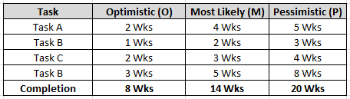
Example of the three-time estimates

Step 2: Calculate PERT Estimate
After completing Step 1, use the (optimistic, pessimistic, and most likely) estimates in the formula below to calculate the PERT estimate for the project.

Formula: (P+4M+O)/6

Example: (8 + 4(14)+20)/6 = 14 Weeks

Critical Path
Definition Critical Path: The longest path of scheduled activities that must be met to execute a project.

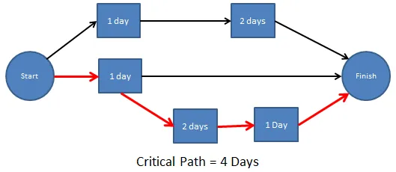

Advantages and Disadvantages of PERT Analysis
Understanding the advantages and disadvantages of utilizing PERT analysis will give program managers and project personnel a better understanding of the realities of their schedules. It takes an experienced program manager to truly utilize the benefits a PERT analysis can provide a project team.
- Advantages: Provides Program Managers information to evaluate time and resources on a project. It helps give them the necessary information to make informed decisions and set a realistic schedule.
- Disadvantages: The analysis can be highly subjective and be influenced a few outspoken team members. It also required a lot of time to continually update the analysis as a program progresses.

Critical Path Method (CPM) and Program Evaluation and Review Technique (PERT)
Although Critical Path Method (CPM) and PERT are conceptually similar, some significant differences exist mostly due to the type of projects best suited for each technique. PERT is better to use when there is much uncertainty and when control over time outweighs control over costs. PERT handles uncertainty of the time required to complete an activity by developing three estimates and then computing an expected time using the beta distribution. CPM is better suited for well-defined projects and activities with little uncertainty, where accurate time and resource estimates can be made. The percentage of completion of the activity than can be determined. [1]
Advertisements

History of PERT
In 1958, the U.S. Navy introduced network scheduling techniques by developing PERT as a management control system for the development of the Polaris missile program. PERT’s focus was to give managers the means to plan and control processes and activities so the project could be completed within the specified time period. The Polaris program involved 250 prime contractors, more than 9,000 subcontractors, and hundreds of thousands of tasks. [1]
PERT was introduced as an event-oriented, probabilistic technique to increase the Program Manager’s control in projects where time was the critical factor and time estimates were difficult to make with confidence. The events used in this technique represent the start and finish of the activities. PERT uses three-time estimates for each activity: optimistic, pessimistic, and most likely. An expected time is calculated based on a beta probability distribution for each activity from these estimates. [1]

Example 1:
A small project consisting of eight activities has the following characteristics:
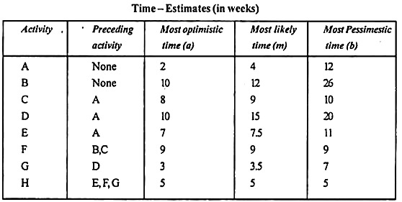
(i) Draw the PERT network for the project.
(ii) Prepare the activity schedule for the project.
(iii) Determine the critical path.
(iv) If a 30- week deadline is imposed, what is the probability that the project will be finished within the time limit?
v)If the project manager wants to 99% sure that the project is completed on the schedule date, how many weeks before that date should he start the project work?
Solution:
The network diagram for the given data is shown in fig. below. The earliest time and variance of each activity is computed by using the formula.
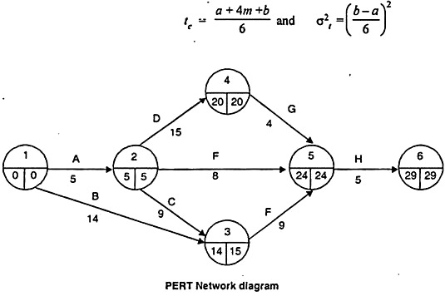
(ii) Calculation activity duration and scheduling times.
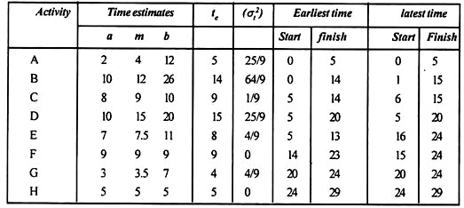
(iii) The critical path of the project is 1-2-4-5 -6, critical activities being A, D, G and H.
The expected project length is the sum of duration of each critical activity. Expected project length = 5 + 15 + 4 + 5 = 29 weeks.

Variance project length is obtained by summing variance of each critical activity.
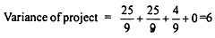
(Iv) The required probability can be determined by finding the area under the normal curve to the left of X = 30
Now, the probability of completing the project within the 30 week deadline is
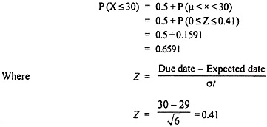
(v) If the project start T weeks before the due date, the X will represent the ordinate under normal curve to the left of which 99% of area lies.

Example 2:
A small project consisting of ten activities has the following characteristics:
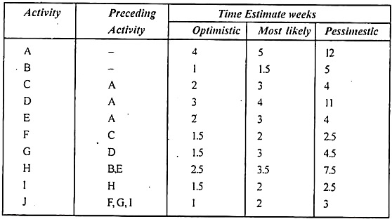
Determine the critical path
Solution:
Network for the given project is drawn below:
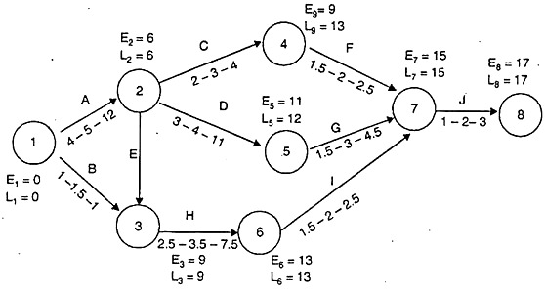
Value of expected time for each activity is shown in following Table:
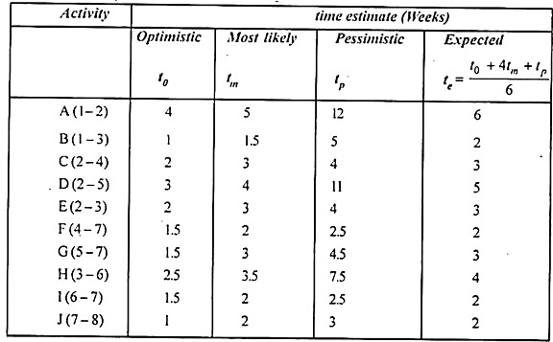
Time [Earliest & latest] are calculated as follows:
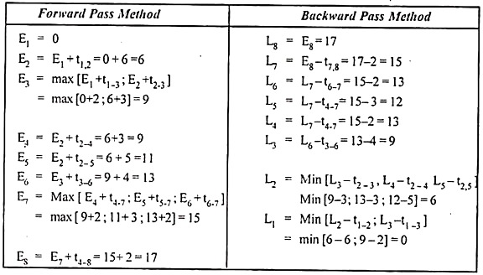
As we can see there are two critical paths along which E-values and L-values are similar, but the longest network of critical activities is known as critical path.
Critical path is 1-2-3-6-7-8
Expected length of critical path is = 6 + 3 + 4 + 2 + 2 = 17 weeks
Example 3:
Product manager has planned a list of activities culminating in the inaugurate launch of the new products.
These are given in the table below:
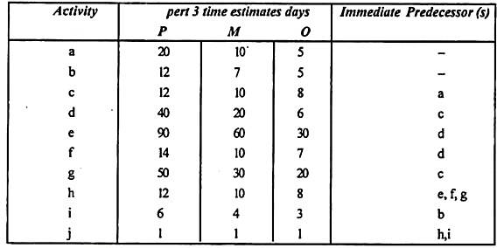
What is the probability that product manager will be able to complete the language launch within 80 days-time?
Solution:
Network diagram for given problem is shown in following fig:
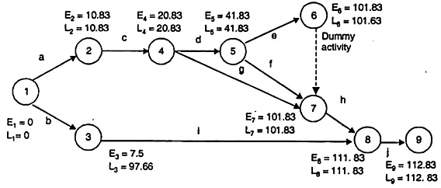
Expected time value for each activity of given network is listed in table below along with three variance.
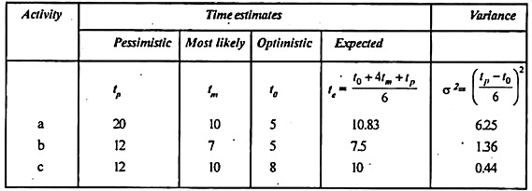
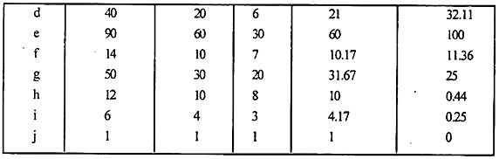
Value of earliest & latest time is calculated on the basis of expected time t_{e} as follows:
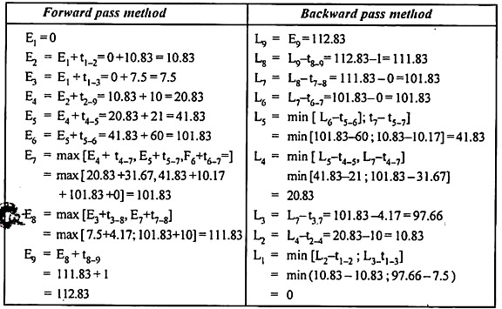
Value of earliest & latest time is calculated on the basis of expected time t_{e} as follows:
Hence critical path along with E-value and L- value are same i.e., 1- 2-4-5-6-7- 8-9 Expected project duration is 172.83 days
Variance of project length = Sum of variance of each critical activity = 6.25 + 0.44 + 32.11 +100+1.36+.44+0= 140.6
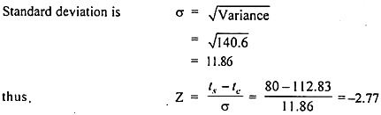
For Z = -2.77 Probability of completing the project with 80 days-time i.e., 0.3%.

Example 4:
A Project is composed of seven activities whose time estimates are listed in the following table. Activities are simplified by this beginning (1) ones ending (j) Node member.
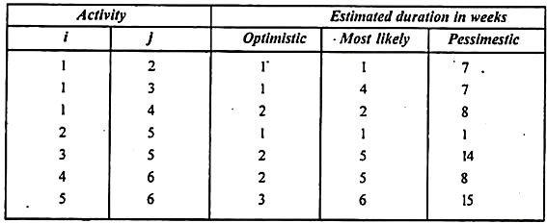
Calculate expected project length.
Solution:
Calculation of expected time for each activity is shown in following table:
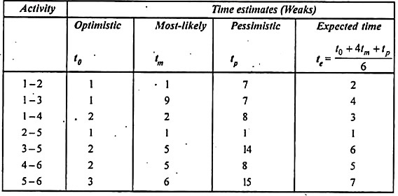
E- Values and L- values are calculated on the basis of expected time are as follows:
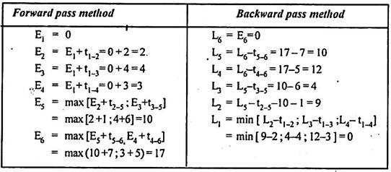
Network diagram for given project along with E-values and L-values is shown by following Fig:
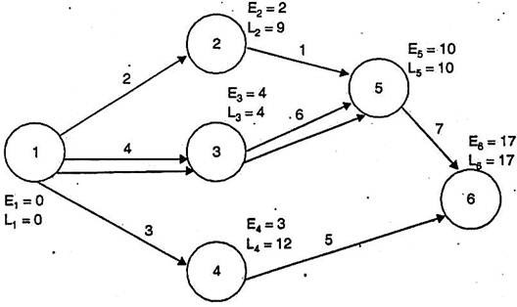
Critical path for the above network 1-3-5-6 shown by double lines; along with E- values and L-values are same.
Expect project length will be = 4 + 6+ 7 = 17 weeks.

Difference Between PERT And CPM In Tabular Form
BASIS OF COMPARISON | PERT | CPM
Type Of Tool | PERT is a probabilistic project management tool. | The CPM is a deterministic project management tool.
Focus | PERT is an event oriented tool, whereby the network interest is focused upon start or completion of events and not on activities themselves. | CPM is an activity oriented tool, the network interest is focused upon the start and completion of activities and not events themselves.
Usefulness | PERT is useful for research and development project as they comprise of the unpredictable tasks and activities. | CPM is useful for the construction projects because it comprises of the predictable tasks and activities.
Terminology | PERT technique involves use of words like events, network diagram and slacks. | CPM technique involves use of terminology like arrow diagram, nodes and float.
Grouping of Activities | PERT does not categories activities into critical and non-critical activities. | CPM categorizes activities into critical and non-critical activities.
Duration of Activity | In PERT, duration of activities are not estimated with a fair degree of accuracy (activities are not so accurate and definite). | In CPM, duration of activity is estimated with a fair degree of accuracy.
Room For Uncertainty | In PERT, allowance is made for uncertainties in the duration of time involved. | In CPM, no allowance is made for uncertainties in the duration of time involved.
Time-Cost Relationship | In PERT, time is not related to cost. | In CPM, the objective is developing an optimum time-cost relationship.
Application | PERT is suitable in defense projects and R&D where activity time cannot be reliably predicted. | CPM is suitable for problems in industrial setting, plant maintenance, civil construction projects etc.

